# Data Extraction

Both global and local (New Orleans, LA) weather data was retrieved from the provided SQL weather database via queries for the relevant columns including ‘year’ and ‘avg_temp’. In the case of this project, the city and country columns were also pulled from the database so that it would be differentiated if the scope of the analysis increases to more than this one city.

The SQL queries used to get the weather data that was utilized in the analysis are:

* “SELECT * from global_data”
* “SELECT * from city_data WHERE city = 'New Orleans'”

# Data Manipulation

That data was read into a Python script using the Pandas module:

* “cityData = pd.read_csv ('cityData.csv')”
* “globalData = pd.read_csv ('globalData.csv')”

Moving averages were calculated for each data set using the ‘rolling’ function provided by Pandas. The amount of time that the moving averages included was determined by the local data appearance. Since there were chunks of missing data, the number of years included in the average was chosen in such a way that the initial plot of the local weather data wasn’t spotty or difficult to interpret. A value of seven (7) was decided upon, and, though the global data looked better with smaller numbers, seven (7) was used there as well for the sake of consistency. The rolling averages were then added as a new column to the imported weather data:

* “cityData['city_temp'] = cityData['avg_temp'].rolling (7).mean ()”
* “globalData['global_temp'] = globalData['avg_temp'].rolling (7).mean ()”

# Data Visualization

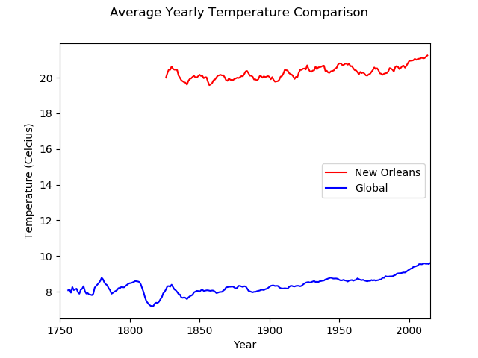

# Data Interpretation

* The local temperature trend of New Orleans over time is similar to the global temperature trend over time. Though the local temperature of New Orleans is much higher than the average global temperature, the rate of increase seems to be similar between the two.
* The local average temperature seems to be more volatile than the average global temperature. Since the rolling averages of each set of data includes the same number of years, one would expect that taking rolling averages of each set would represent them in comparable ways.
* The average global temperature is more erratic between ~1750 and ~1850 than between ~1850 and the present. The time frame is associated with the industrial revolution and may be a result of the dramatic changes in the levels greenhouse gas emissions while after 1850, the earth was in a steady state of temperature increase.
* The difference in global temperature and local temperature in New Orleans has been consistent. Though the local temperature is more erratic in general, the trend is consistent. The fact that they track one another suggests that climate changing generally isn’t something that happens differently on different scales.